IA4

Design Challenge: Smart Home Manager

Design layout of and user interface for both the physical wall-mounted device and it’s touch screen display

1. State the design challenge:
   1. Design the layout of and user interface for both the physical wall-mounted device and it’s touch screen display for a smart home manager.
2. Generate ten or more different design concepts of a system that address the challenge.
   1. Be creative and diverse.

Concept 1:

**Conceptual model:**

This design will allow the user to approach the device with the idea of what they want to do and will allow them to easily navigate the menus to achieve that goal. The interface only shows relevant information at each screen to prevent the user from being overwhelmed. Labels are used to eliminate confusion about operations. If a user wishes to add a new device or remove an existing one, they presumably know where that device is located and so can navigate to that room and select the “add/remove device” button which will bring up a list of available devices to add or remove. Existing devices are listed separately from devices that have not been added to the system to easily distinguish between them. Selecting an item will bring up the options for that item so the user can add or remove the item from the manager or adjust the settings for that device. A scheduling option is available for each device. The display for each room shows the status of each device at a glance.

**Affordances:**

The touch screen affords touching. The touch screen is ubiquitous and because of transfer effects, requires no explanation or instructions. With no visible physical buttons, users will assume a touch interface and press the area of the screen that displays the information that pertains to their desired action.

**Signifiers:**

Each screen is **consistently** labelled at the top to let the user know where they are in the menu. Parenthesized notes have been added to prompt the user to items that can be pressed for actions.

**Mapping:**

To choose a specific room, a map of the house is shown to provide a natural mapping to help the user select the correct room. If we had chosen text with the label of each room, it would be easy to confuse some rooms such as bedrooms for which there can be more than one. Using a pictorial map and allowing the user to press on the room they wish to control removes any confusion.

**Feedback:**

When a user pushes on the screen, the screen will change to the new operation immediately showing them that the action was accepted. An audible notification can also be added if that is desired with a volume low enough to not be offensive but loud enough to be definitively noticed.

**Constraints:**

**Physical:**

The touch screen constrains all action to within the touchable area.

Cultural:

Semantic:

Logical:

**Transfer effects:**

Touch screens are ubiquitous.

Seven stages of action:

1. Establish goal
2. Plan course of action to meet goal
3. Specify sequence of action steps
4. Perform the steps
5. Perceive the state of the system
6. Interpret the perception
7. Compare outcome against goal

**Bridge of execution:**

The user must know at each step what the next action needs to be. As the screen changes, so does the information the new screen provides. Each screen is clearly labelled with it’s title and any operations that can be performed on that screen are labelled as well.

**Bridge of evaluation:**

The user must know that the action they did was successful. When the screen changes to the next operation or values for settings change as the screen is touched let the user know they were successful.

Colors are used in a manner that will minimize the impact on color-blind users. Red and blue text on a white background provide sufficient contrast for users of all color-blind ranges.

The design uses **visual structure**, organizing each window into clear subgroups with spacing between them to denote them as different elements. The schedule controls are **data specific**, they use calendar terminology and icons to distinguish them by their function.

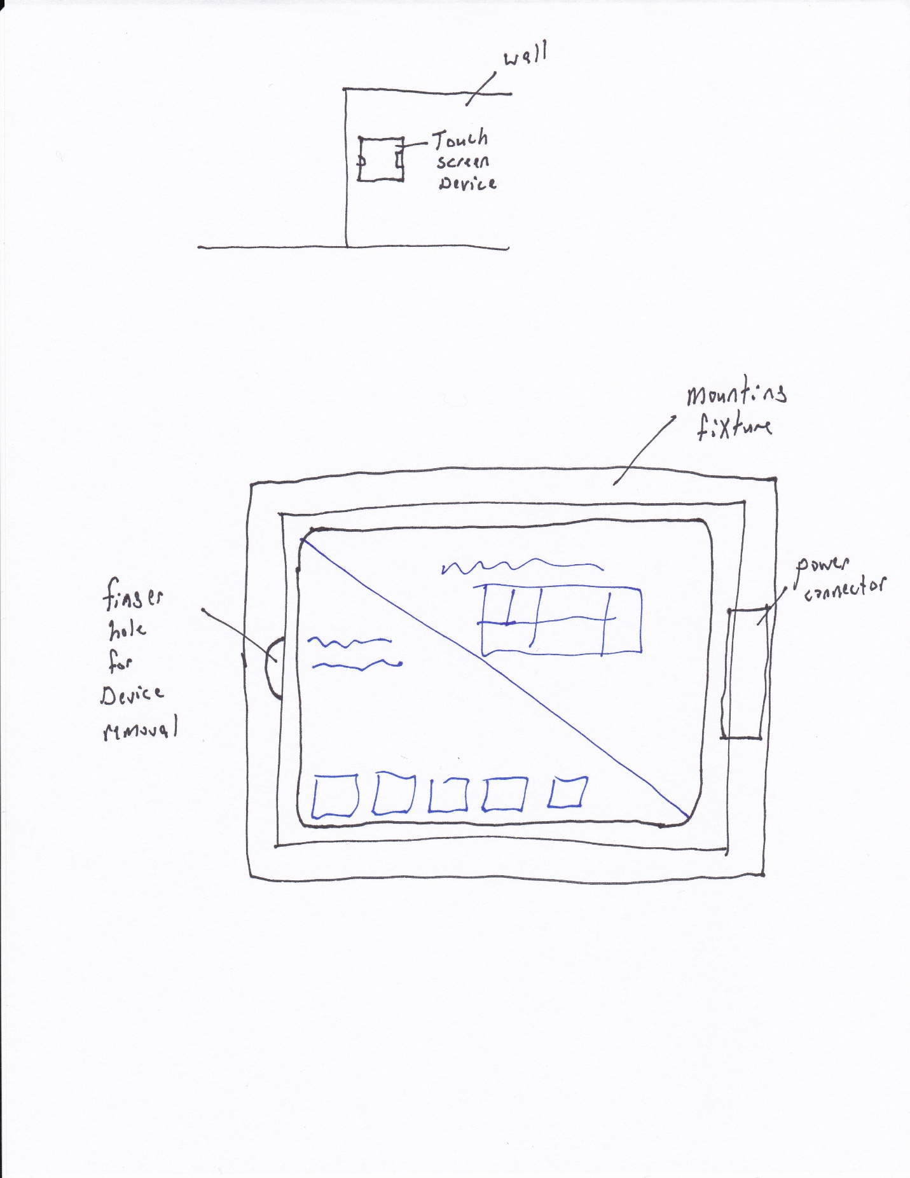

Figure X: Physical device installation in wall, removable touch-device (iPad, Surface, etc.)

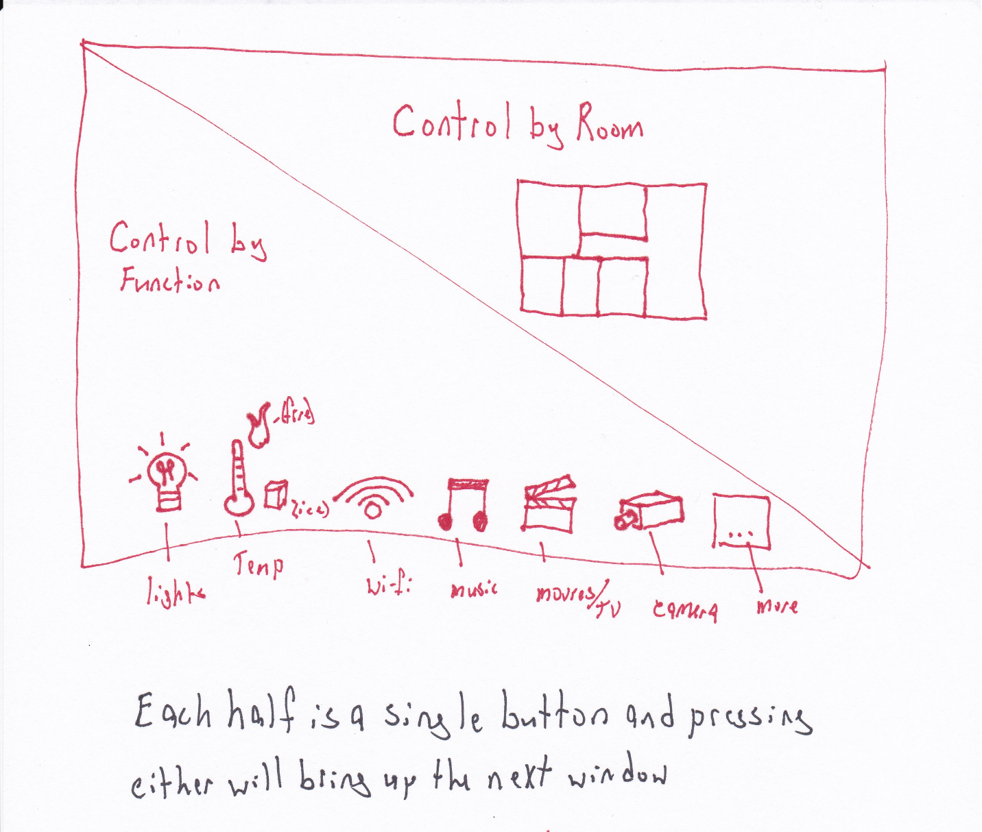

Figure 1: Main menu

**Bridge of execution:**

The users **plan** will be to adjust the setting of a device. To **perform** this action, the user can see from the display that there are two options. Each is labelled with the keyword “control” and the sub-function follows. Assuming the user wants to set a schedule for the freezer, they could choose to control by room and press the upper-right portion of the screen.

**Bridge of Evaluation:**

The **interpretation** is slightly ambiguous, the user may select “Control by Function” instead believing that will be the best way to control the temperature since that is a specifically listed function but pressing that button will bring up a new screen that will have a list of each of those elements and will show an option for the refrigerator and one for the thermostat which would eliminate their confusion while still allowing them to select the correct device without having to return to the previous menu.

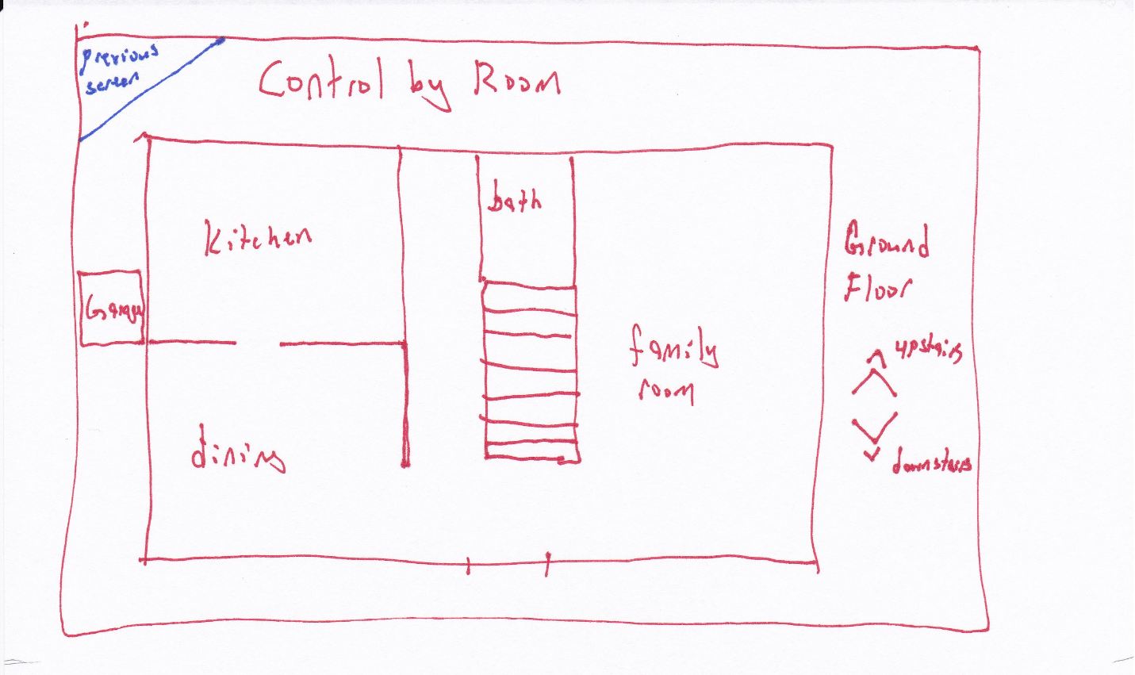

Figure 2: Select room, user presses on the room they wish to control

**Bridge of Evaluation:**

The user’s **plan** is to adjust the freezer schedule. The freezer is located in the kitchen. The kitchen is one of the rooms available to select. The user can easily see the next option.

**Bridge of Execution:**

It is not unusual to have a freezer in the garage. The user could **misinterpret** the screen if they believed this to be the case. In that event, selecting the garage will show a list of available devices and if a freezer is not listed, they will have to return to the previous screen, this screen, and make a more appropriate choice. This might be a **cultural constraint** as some people keep bulk foods on hand, some don’t.

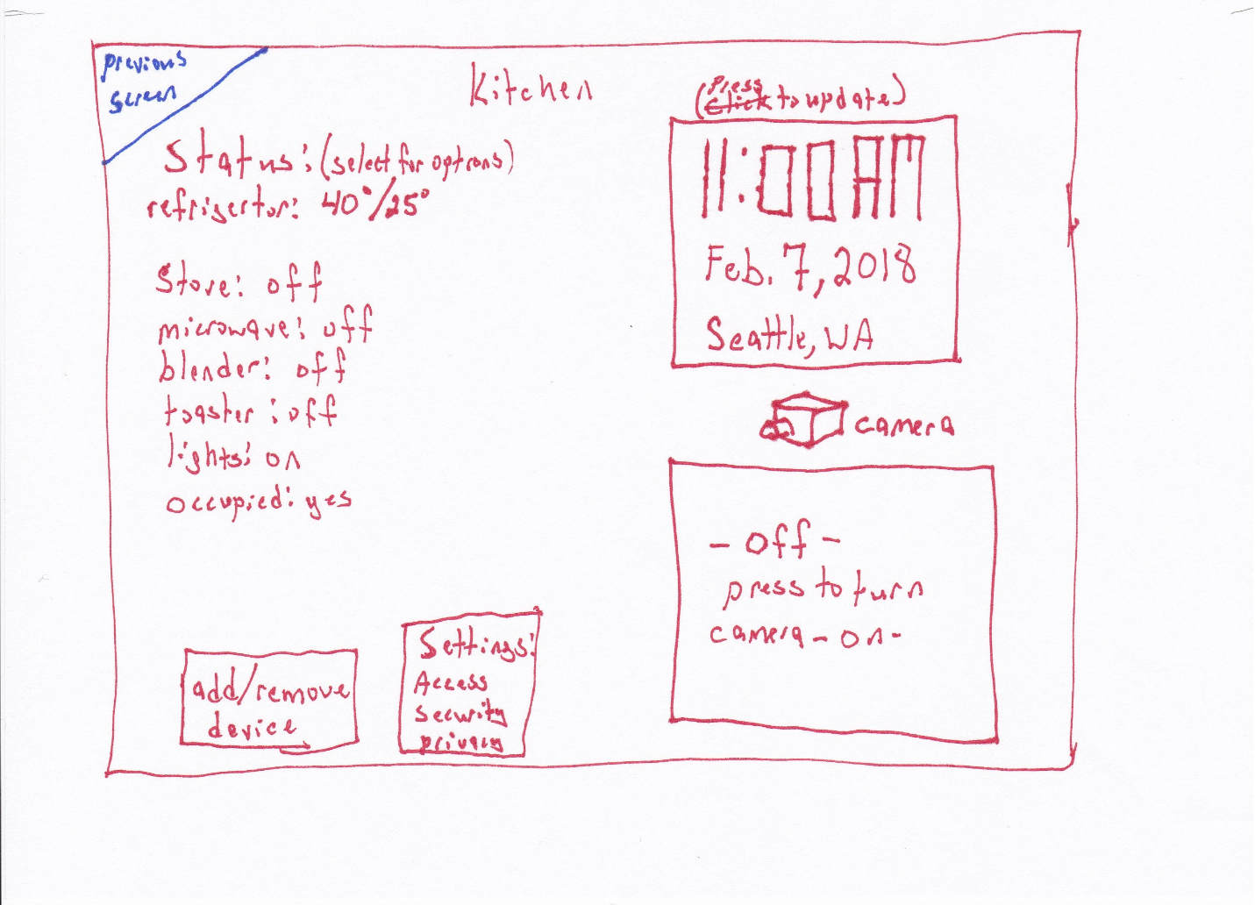

Figure 3: Status by room with options to change the settings for each device, add or remove devices, change system settings (this is available in all room displays). The camera and video option can be made to only appear if the room has an enabled camera. It the camera is not installed for a room or has been otherwise disabled, this option will not appear but will be a blank part of the screen. The position of the other elements will not change to preserve window-to-window consistency.

**Bridge of Execution:**

The refrigerator status is shown on the status display and the Status heading states that the user can press the device for more options. The user can easily see what they need to do next to set a schedule for the freezer.

**Bridge of Evaluation:**

The on-screen **feedback** guides the user to the next step.

**Gestalt principle of Proximity:**

Common, related items are grouped next to each other in the status area and the two buttons for add/remove device, and settings.

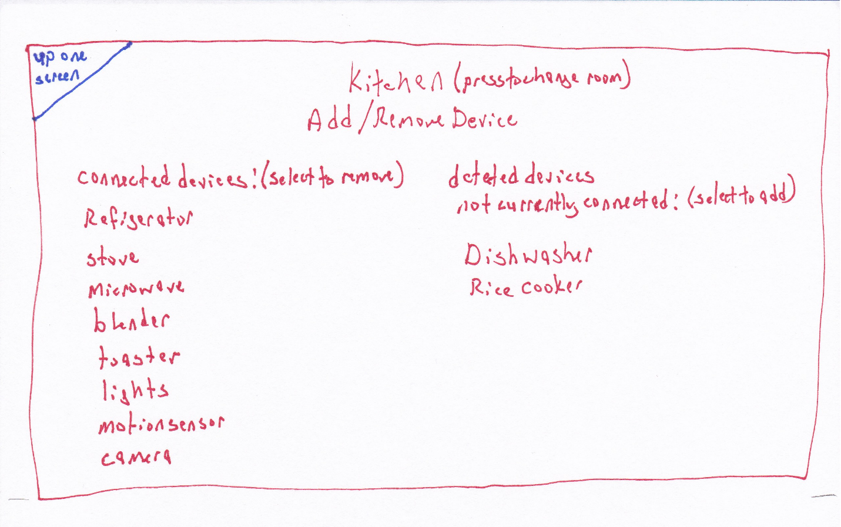

Figure 4: Settings per device per room in the “Add/Remove device” option. Connected and not-connected devices are listed separately.

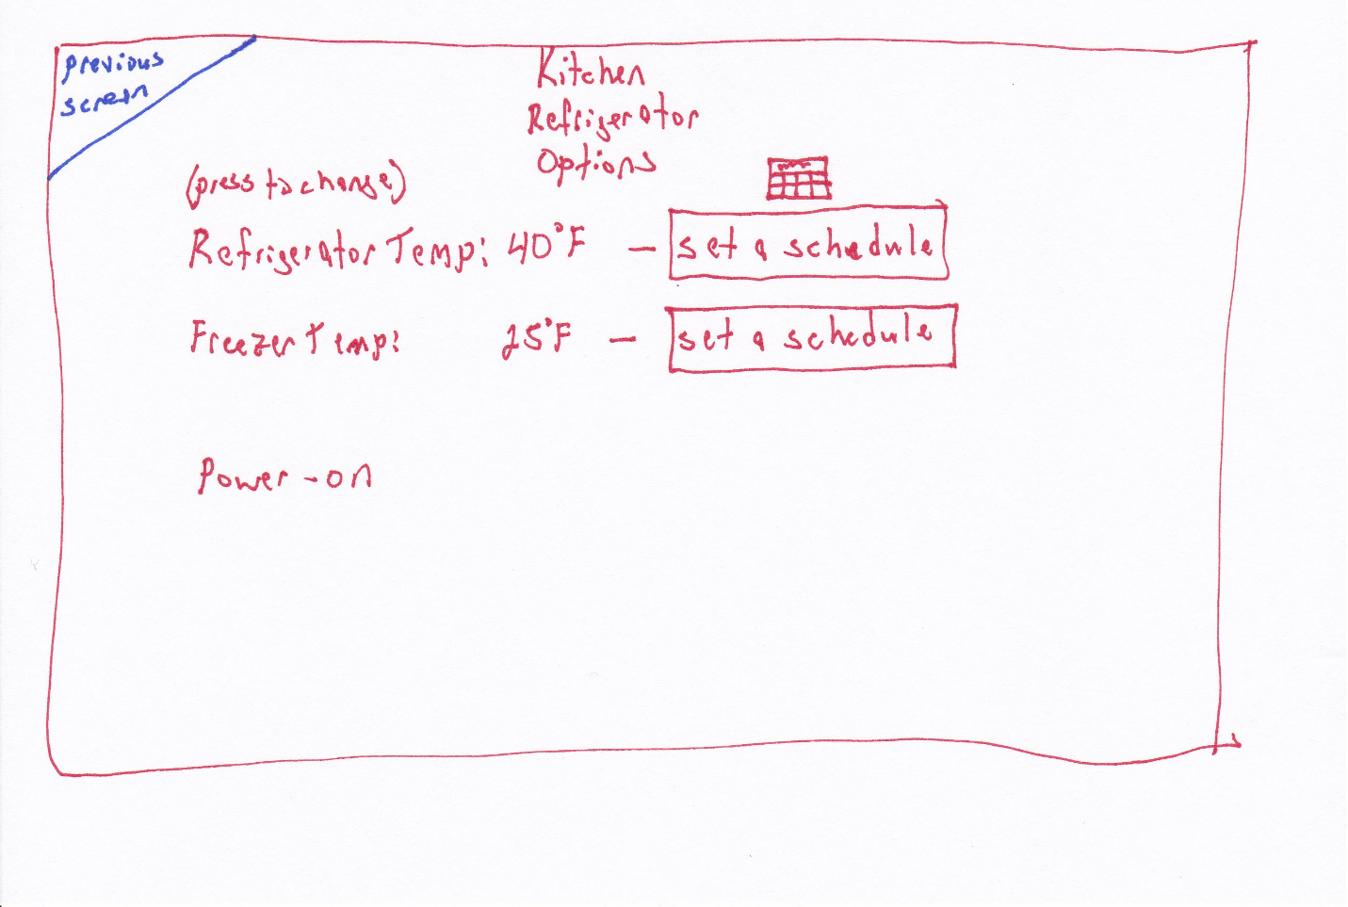

Figure 5: Specific device settings, a graphic and text is used to denote scheduling, the graphic chosen is of a calendar page to indicate that long-term schedules can be created as opposed to a clock that could indicate per-day time scales.

**Bridge of Execution:**

The user’s **plan** to set the freezer schedule can now be realized, there is a clear option to set the schedule for the freezer.

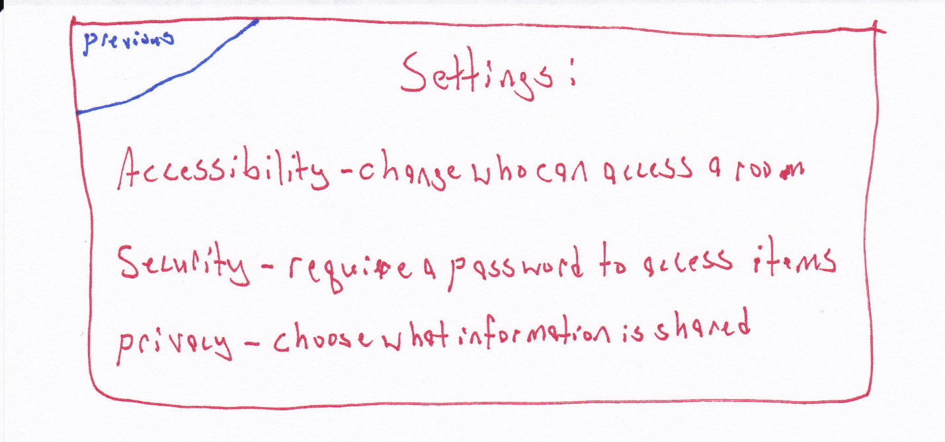

Figure 6: Update Settings

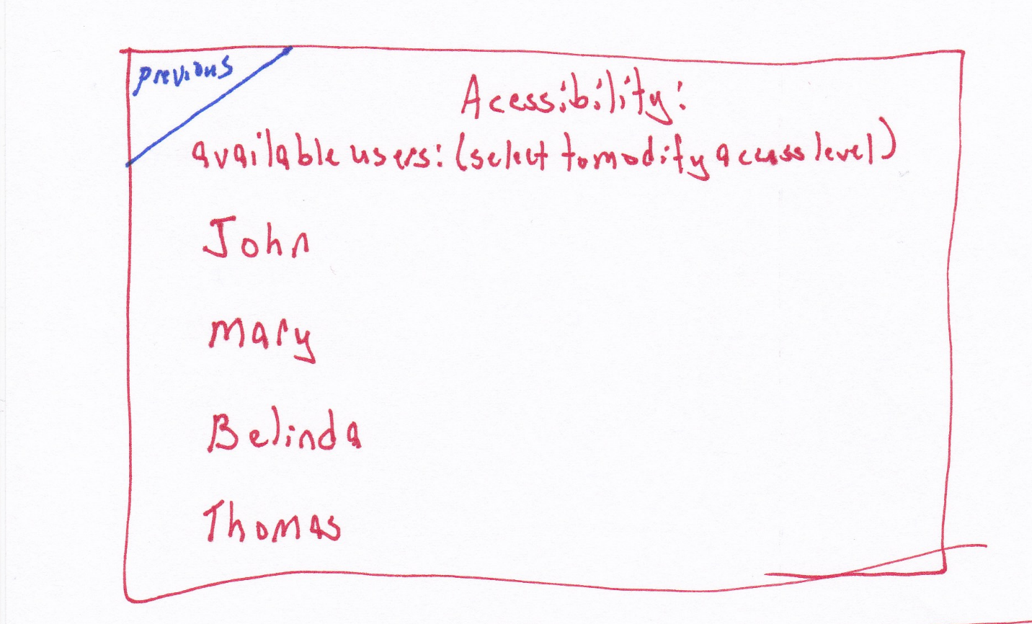

Figure 7: Accessibility settings can be set per user. If a user is to be prevented from adjusting a setting on a device, for example, the much controversial thermostat, then adjusting that setting will require a user name and password of an authorized user.

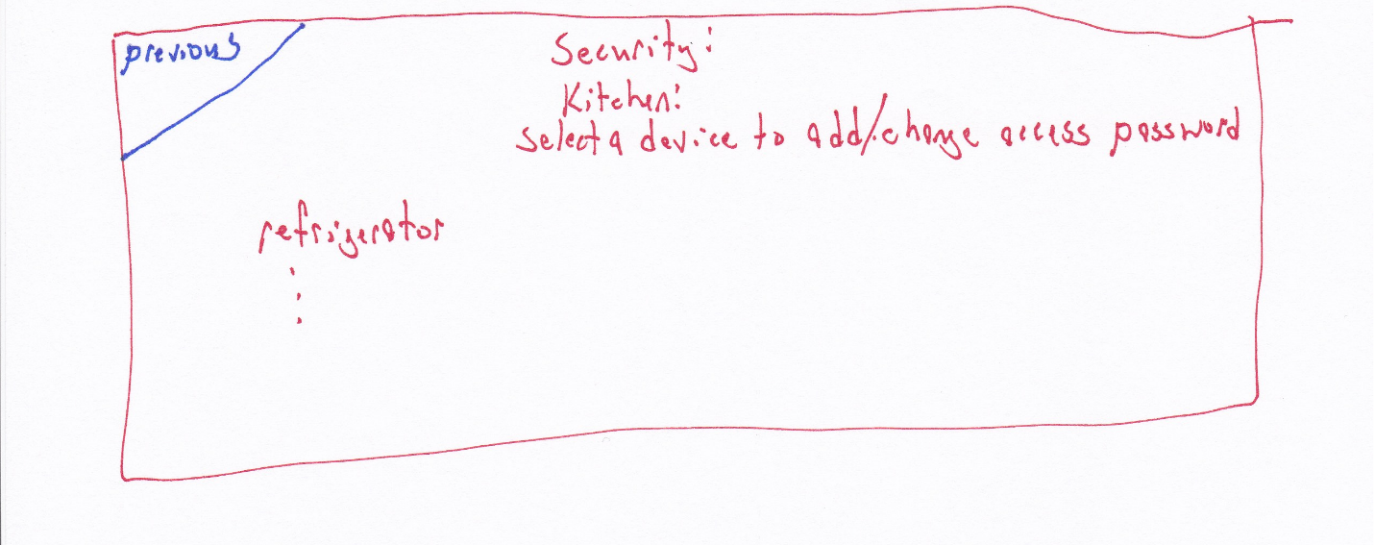

Figure 8: Security settings can be set for specific devices to require an authorized user and authenticating password to adjust.

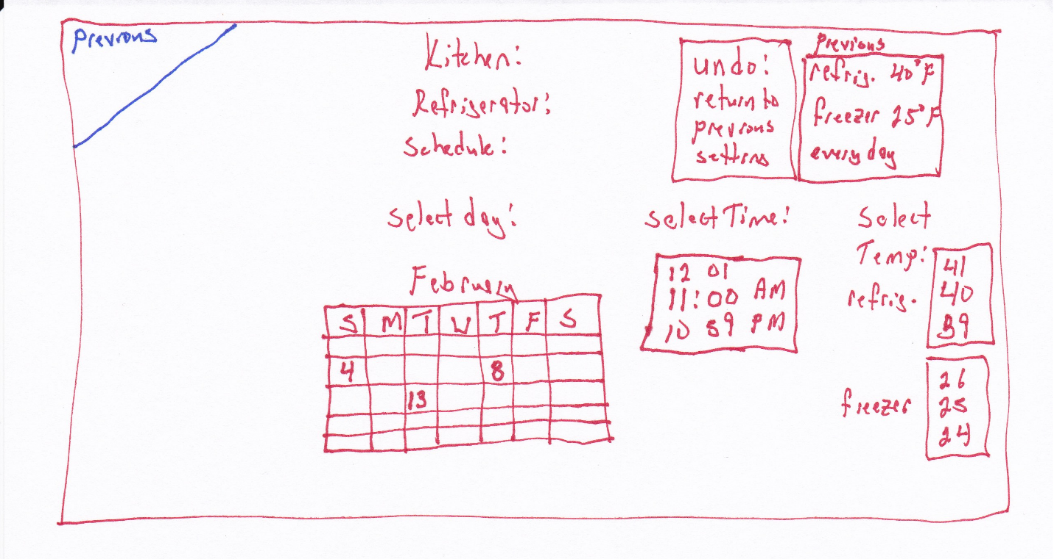

Figure 9: Scheduler allows the user to adjust the day and time a devices settings will be modified.

**Bridge of Execution:**

**Pictorial representations** of the calendar and clock augment the text that prompts the user to select a date, time, and temperature. It also provides an easy way to restore the settings with one touch.

**Bridge of Evaluation:**

Having the time one minute ahead above the current time and the time one minute below is supposed to indicate that the user can swipe the touch screen there to change the time. The temperature settings use the same mapping. This may be confusing to new users or it could be intuitive for users already very familiar with touch screens.

The previous setting data provides the user with information so they don’t have to recall it from the previous status screen. This is helping **to not burden the users memory**.

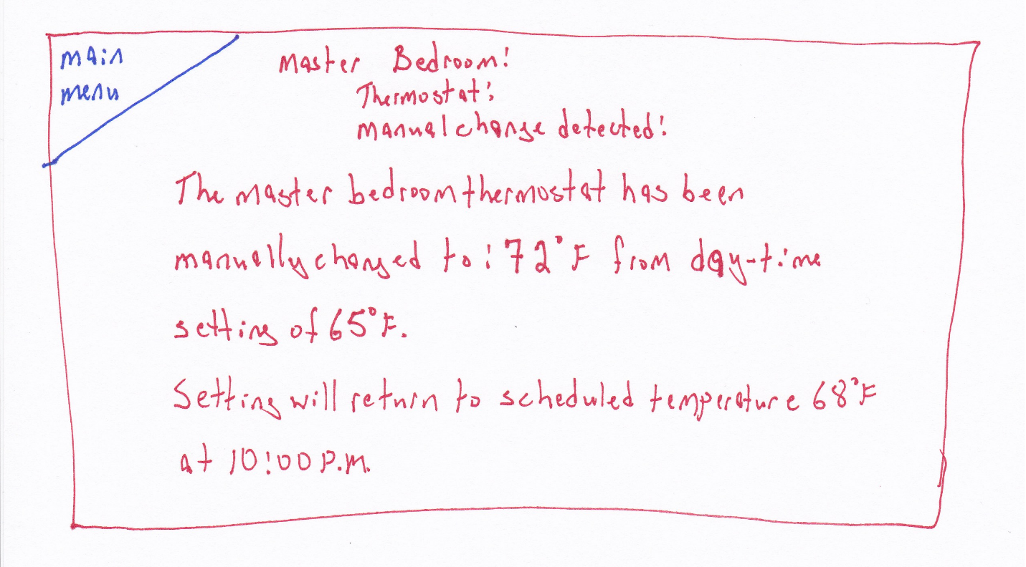

Figure 10: Status message after a device has been changed manually, the device that has been manually set is monitored by the manager for changes and those changes are displayed on the screen until they are acknowledged. If a user turns off a device so the system can no longer access it, it will be noted as “offline”.

Concept 2:

**Conceptual model:**

This design uses a simplified approach. There are fewer options and the user is guided more directly. The controllable devices have the statuses displayed as well as a graphical map of where they are in the room. The images will change color and image to show if a device is on or off. A lamp that is turned off will be a darkened circle, one that is on will be a yellow circle with lines radiating out from it. The user can press on either the device text status or click on the item in the image map to adjust its settings or set a schedule. For light sources that have variable brightness, a slide bar is provided to adjust the brightness. A back arrow combining graphic and text similar to a web browser is provided to allow the user to go back one screen.

**Affordances:**

The touch screen affords touching. The touch screen is ubiquitous and because of transfer effects, requires no explanation or instructions. With no visible physical buttons, users will assume a touch interface and press the area of the screen that displays the information that pertains to their desired action.

**Signifiers:**

Each screen is **consistently** labelled at the top to let the user know where they are in the menu. Parenthesized notes have been added to prompt the user to items that can be pressed for actions.

**Mapping:**

To choose a specific room, a map of the house is shown to provide a natural mapping to help the user select the correct room. This version shows each floor as a selectable object. Using a pictorial map and allowing the user to press on the room they wish to control removes any confusion.

**Feedback:**

When a user pushes on the screen, the screen will change to the new operation immediately showing them that the action was accepted. An audible notification can also be added if that is desired with a volume low enough to not be offensive but loud enough to be definitively noticed.

**Constraints:**

**Physical:**

The touch screen constrains all action to within the touchable area.

Cultural:

Semantic:

Logical:

**Transfer effects:**

Touch screens are ubiquitous.

**Bridge of execution:**

The user must know at each step what the next action needs to be. As the screen changes, so does the information the new screen provides. Each screen is clearly labelled with its title and any operations that can be performed on that screen are labelled as well.

**Bridge of evaluation:**

The user must know that the action they did was successful. When the screen changes to the next operation or values for settings change as the screen is touched let the user know they were successful.

Colors are used in a manner that will minimize the impact on color-blind users. Blue text on a white background provide sufficient contrast for users of all color-blind ranges.

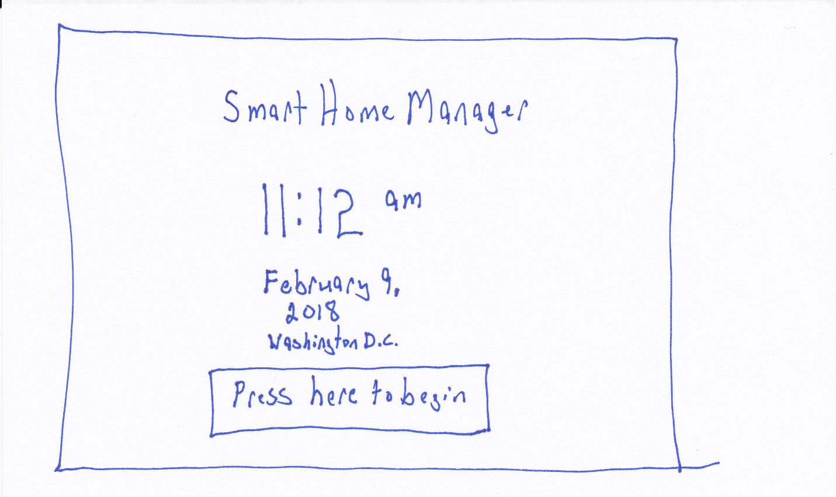

Figure 1: main

**Bridge of Execution:**

The large button labelled “Press here to begin” simplifies the interface and makes it clear what action is required to access the device.

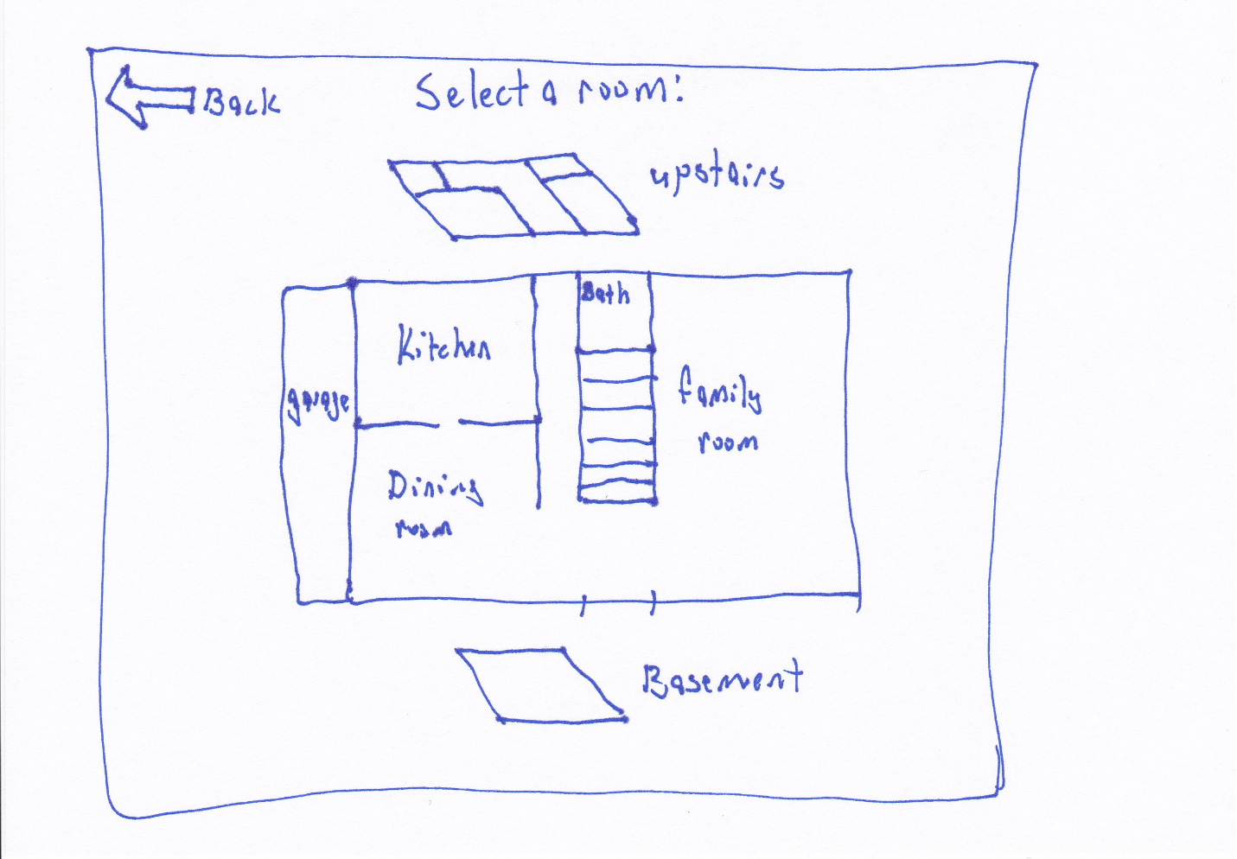

Figure 2: select room

**Bridge of Execution:**

The pictorial representation of the house is intended to be an actual map of the house floor plan. Each room is labelled and touching that room will move to the next screen to show what is available in that room.

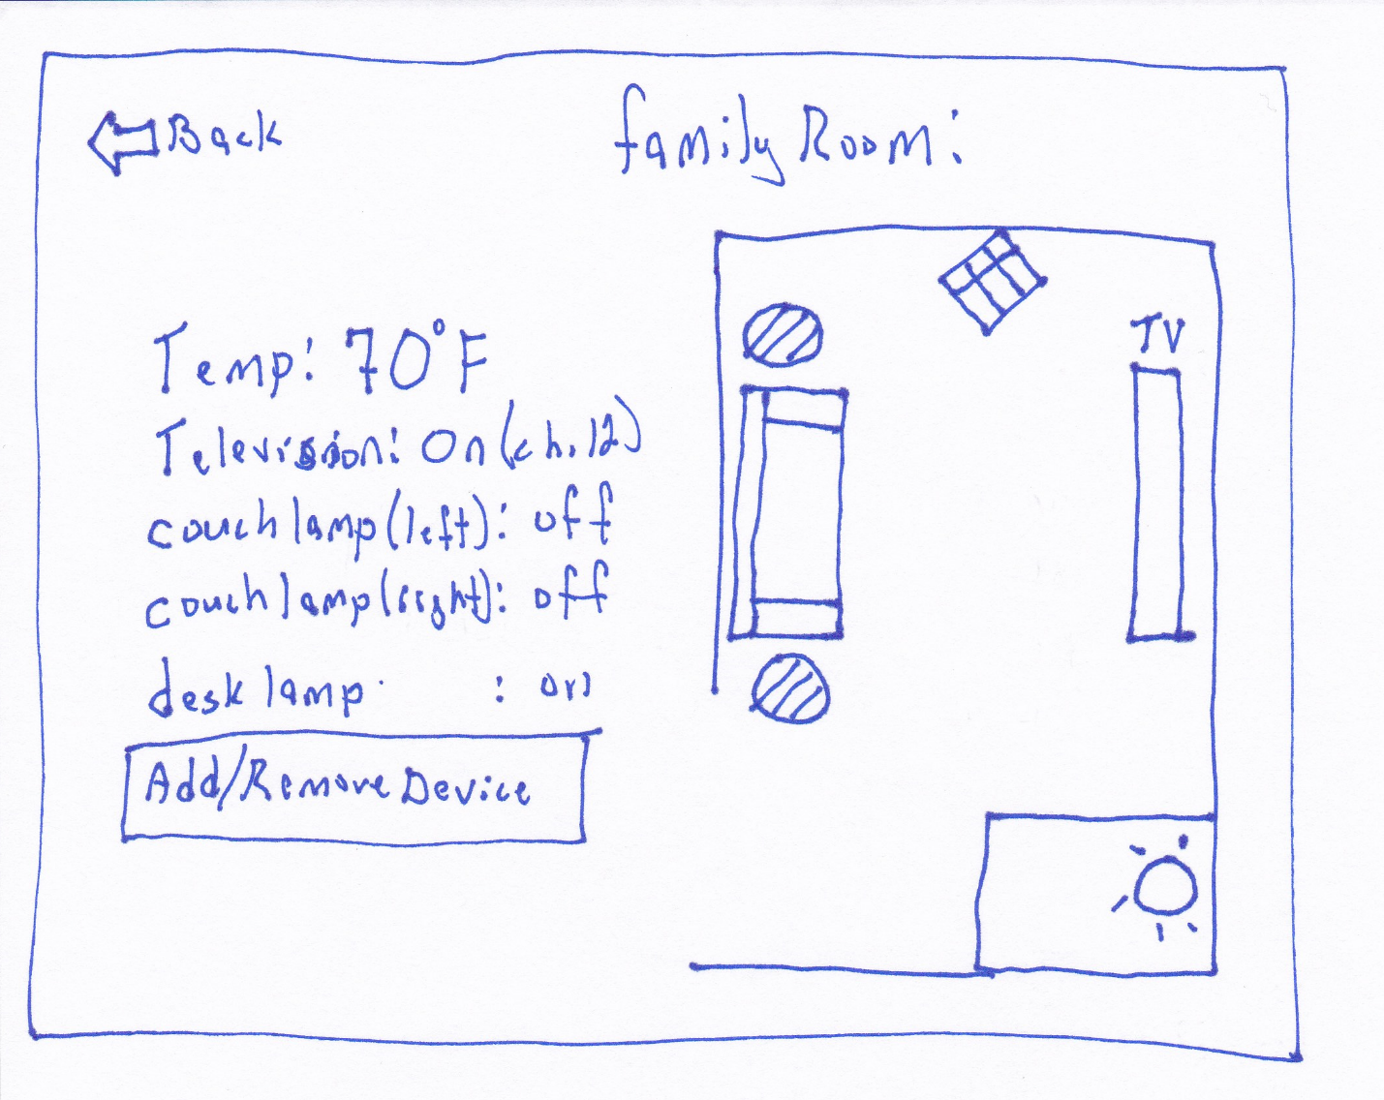

Figure 3: Per room status

**Bridge of Execution:**

The graphics on this display are intended to make it apparent which devices are on by illuminating them. The user can touch the device icon or the device name in the status to adjust the settings.

**Bridge of Evaluation:**

It is not explicitly specified that the user can adjust an item by touching its icon or its status, a **signifier** should be added.

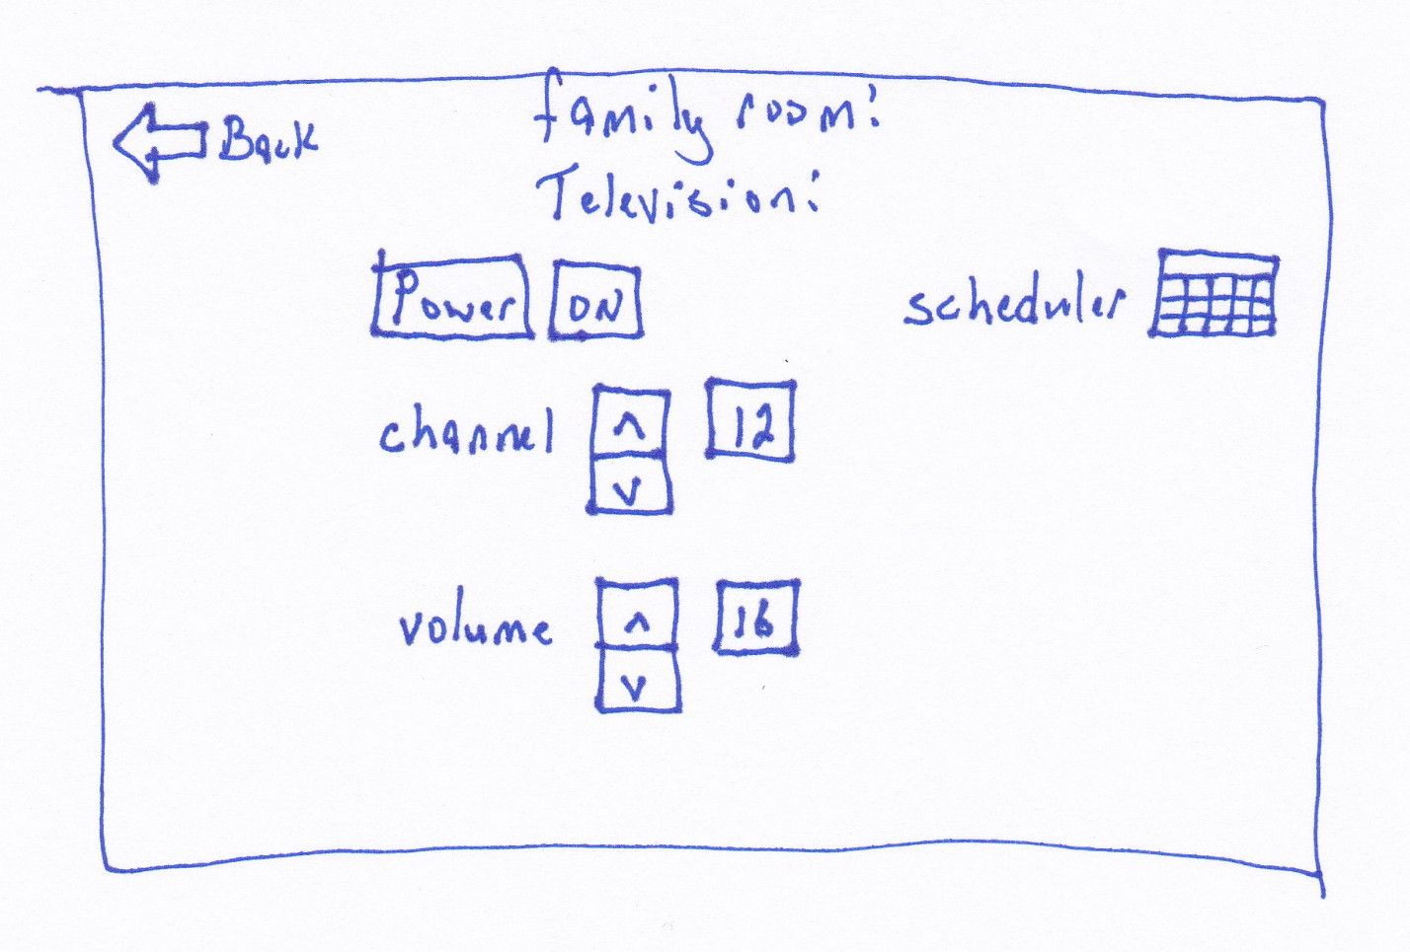

Figure 4: device settings

**Bridge of Execution:**

The television controls resemble a traditional television remote to leverage **transfer effects**. The icon-augmented label of “Scheduler” is intended to be apparent that touching this icon will allow the user to create a schedule for the television.

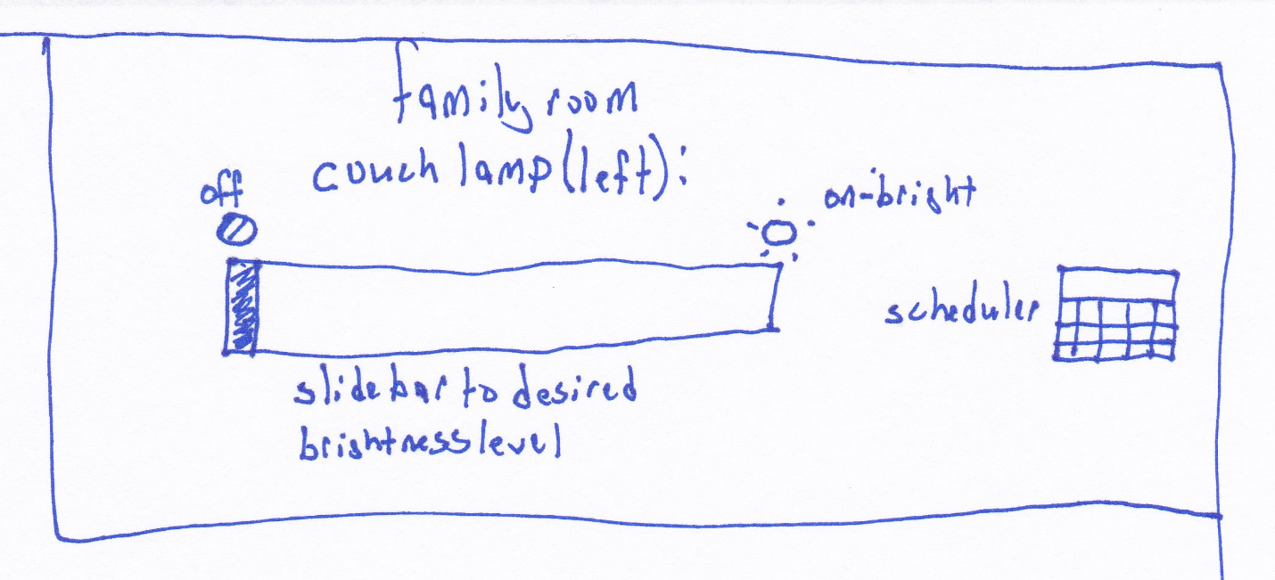

Figure 6: Lamp settings

**Bridge of Execution:**

The slide bar is intended to provide the user with the ability to control brightness similar to a physical slide switch on some dimmable lights.

**Bridge of Evaluation:**

The slide bar might be confusing, it is possible that providing discrete values for the user to click on might be easier to understand.

Remaining steps, to be implemented on final design:

1. Reduce the number of design concepts
2. Choose the most promising design(s) concept as a starting point
3. Produce 10 details and / or variations of a particular design concept
4. Present your best idea(s) to a group
5. As your ideas change, sketch them out